**INTERNET INFORMATION SERVICES (IIS) INSTALLATION**

To activate the Internet Information Services (IIS) package, go to Control Panel> Programs and Features> and on the left side we will find the option "Turn Windows features on or off”

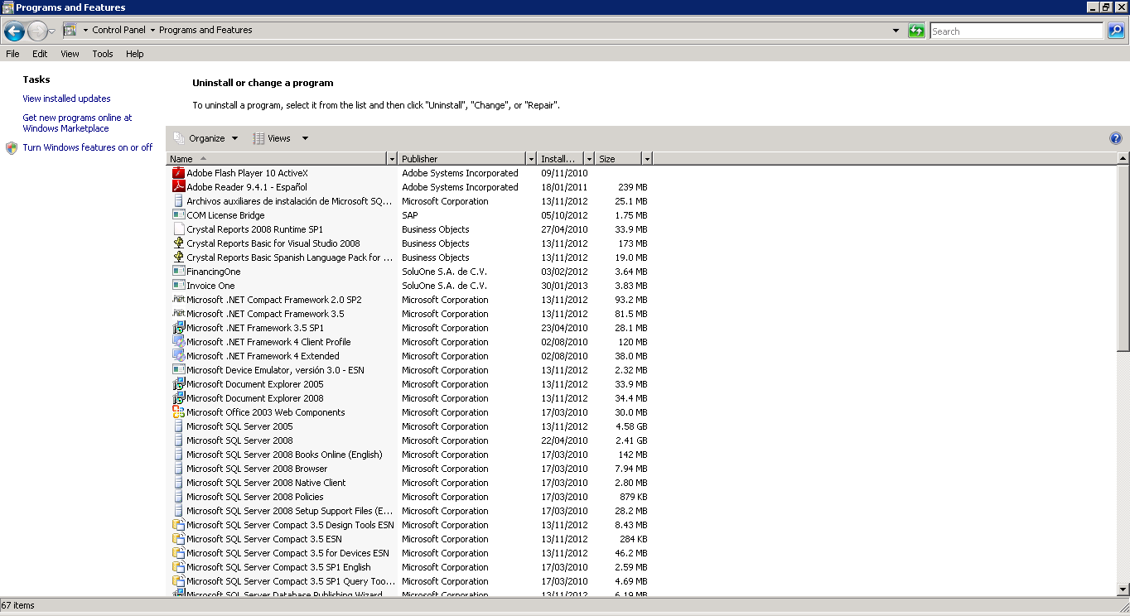

We enter Roles> later inside the central panel we locate Roles Summary and we add to it (Add Roles).

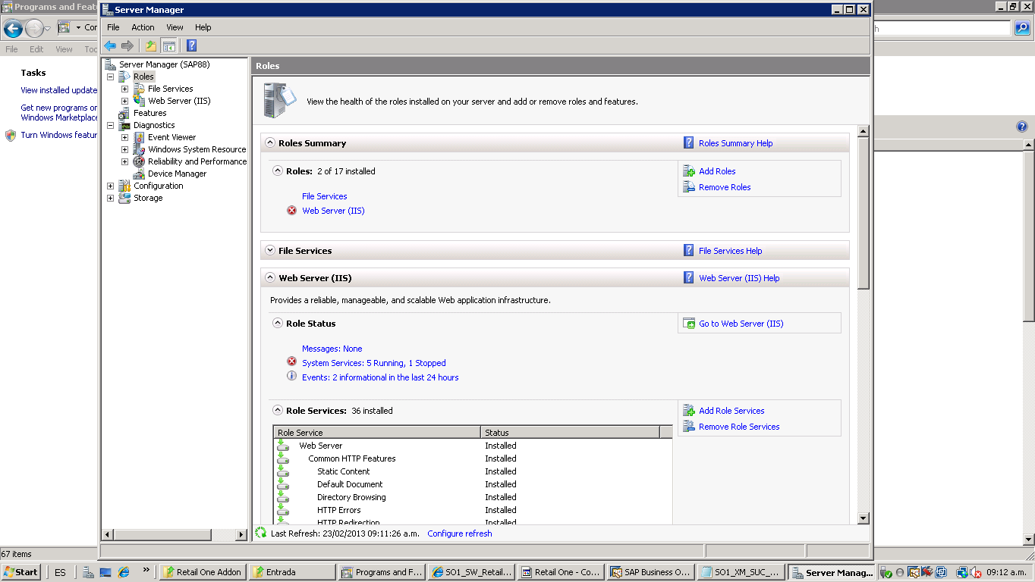

A Wizard will then be displayed, click on the next button; later we will visualize a screen similar to the image, we will select the option "Web Server (IIS)". And press the Install button.

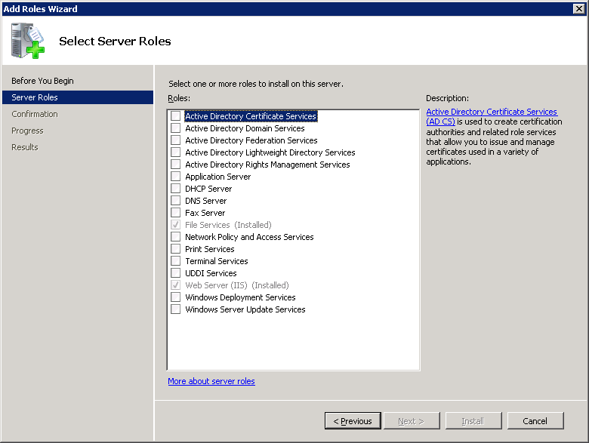

Then, in the Roles section, the section Web Services (IIS) (left side) will be clicked to select it; in the middle part locate the Roles Services section. Select the right side option "Add Roles Services".

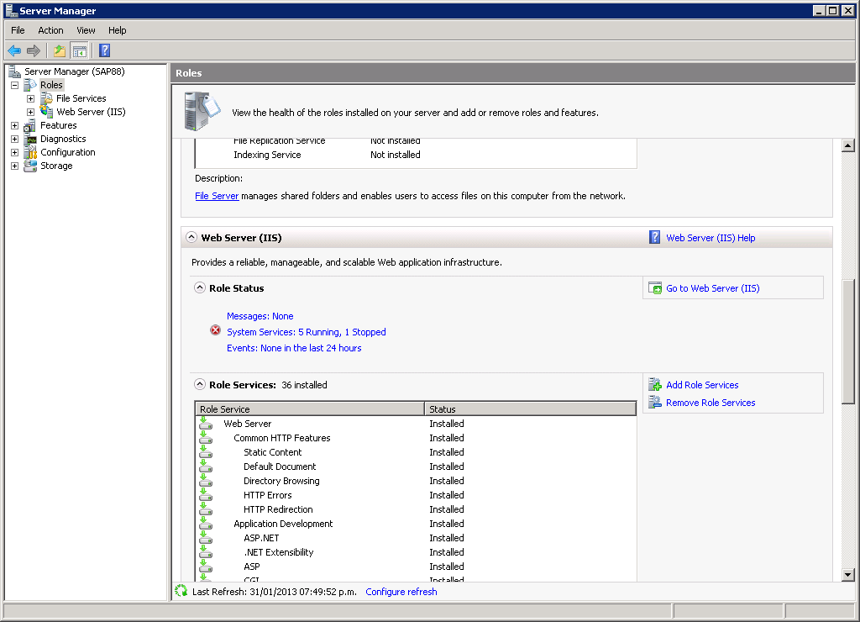

The wizard will then be displayed, selecting the options as they appear in the image. Important to select the options of ASP, ASP.NET, etc.

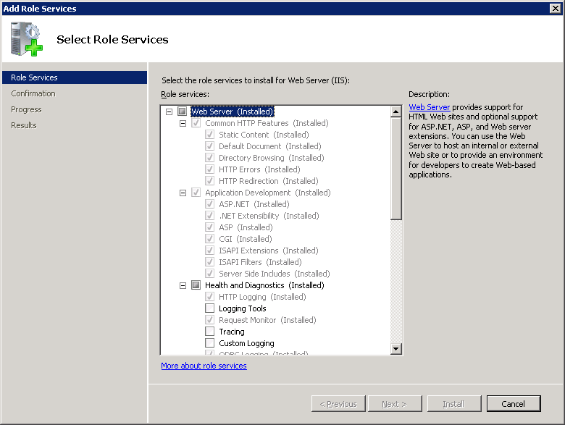

Select Basic Authentication and Windows Authentication (Important)

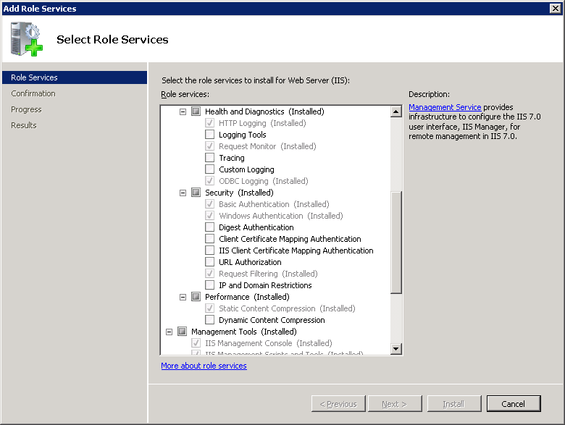

We also select the section of FTP (FTP Publishing Service) and press the following button and Install.

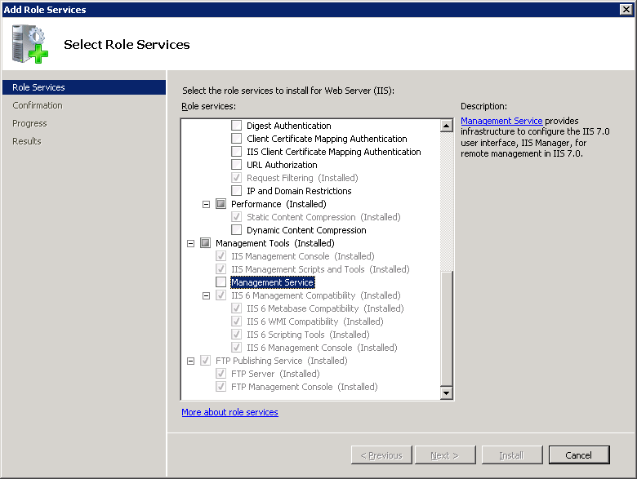

**WEB SERVICE INSTALLATION**

To install the Retail One Web Service, we will go to the C:\Inetpub\ path of the SAP Business One central server.

We will create a folder called "Retail One"

***NOTE: In case of Test Installation indicate the root folder as "Retail One Test".***

Within this folder we create a folder with the same name of "Retail One" being as follows:

"C:\Inetpub\RetailOne\RetailOne" or "C:\Inetpub\wwwroot\RetailOneTest\ Retail One", in the test case.

Within the folder we will place the Web Service files provided for the Installation.

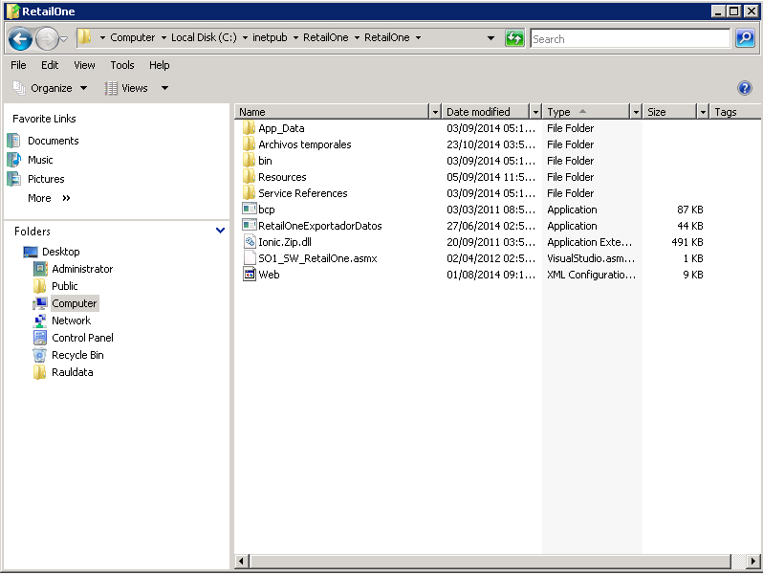

Once the folder is created, we will give you Read and Write permissions, by right clicking on the folder of Retail One> Properties> Security Tab.

We will add the user to Everyone in Edit> Add> Enter User and press the Ok Button> Assign "Full Control"

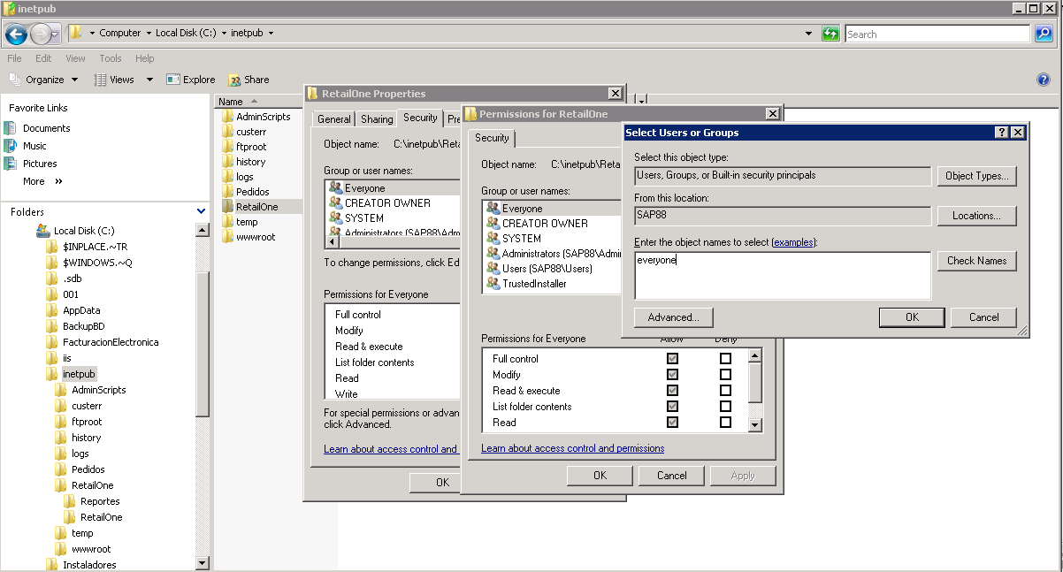

Once the permissions are assigned, we will go to the Internet Information Services (IIS) application, located in Administrative Tools in the Windows Control Panel.

We'll go to the Sites section> Right Click> Add Web Site ...

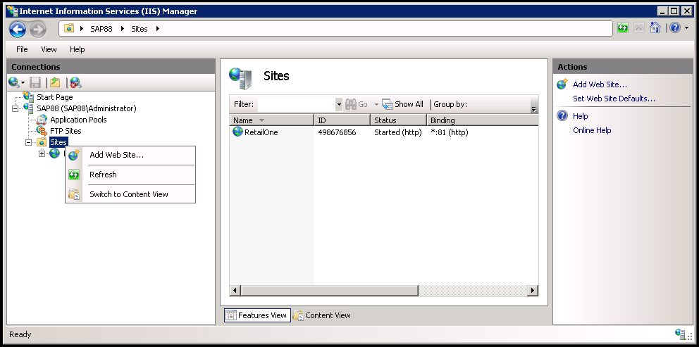

The wizard for creating the web service will now be displayed:

• Site Name

• Indicate the physical path where the website is hosted, select the first folder of Retail One Created; as shown in the image.

• Indicate the Port on which the web service will be working (default) always in 80 indicate another port if necessary.

• Press the "OK" button to finish.

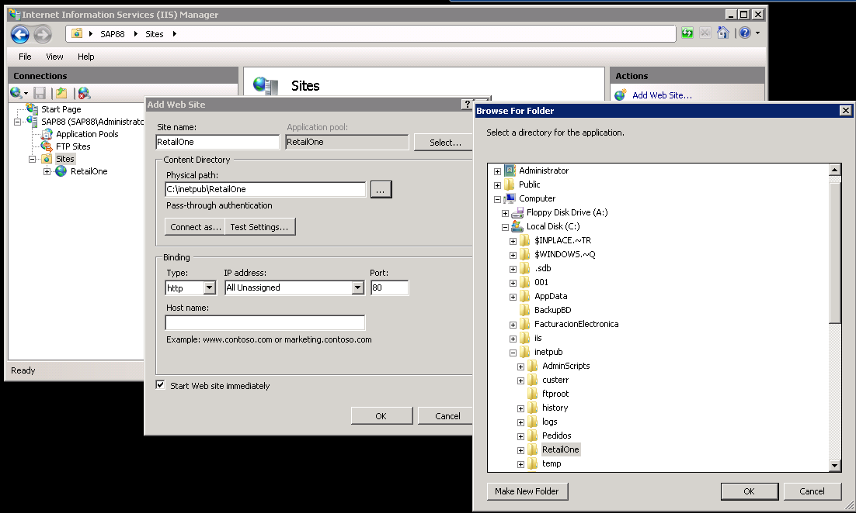

Once created, we expand the website content and click Right> Convert to Application.

A wizard will be displayed, press the "OK" button to continue.

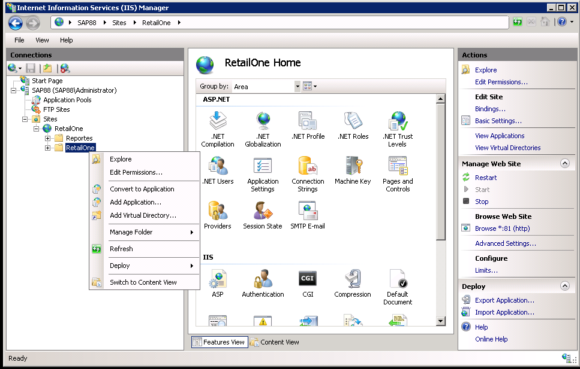

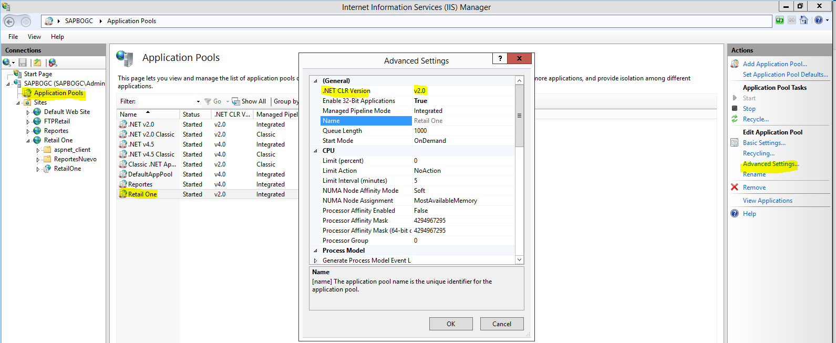

In the given case, it can configure the version in the application groups option \RetailOne\ advanced settings\version of .NET CRL v.4 is set to v.2.0

To check the site created, open an Internet Explorer session on the server and enter the URL: <http://localhost/RetailOne/SO1_SW_RetailOne.asmx> in case the port used is different than port 80, indicate the port used; example port (82) <http://localhost:82/RetailOne/O1_SW_RetailOne.asmx>

Once we enter the URL we will see a page similar to the following:

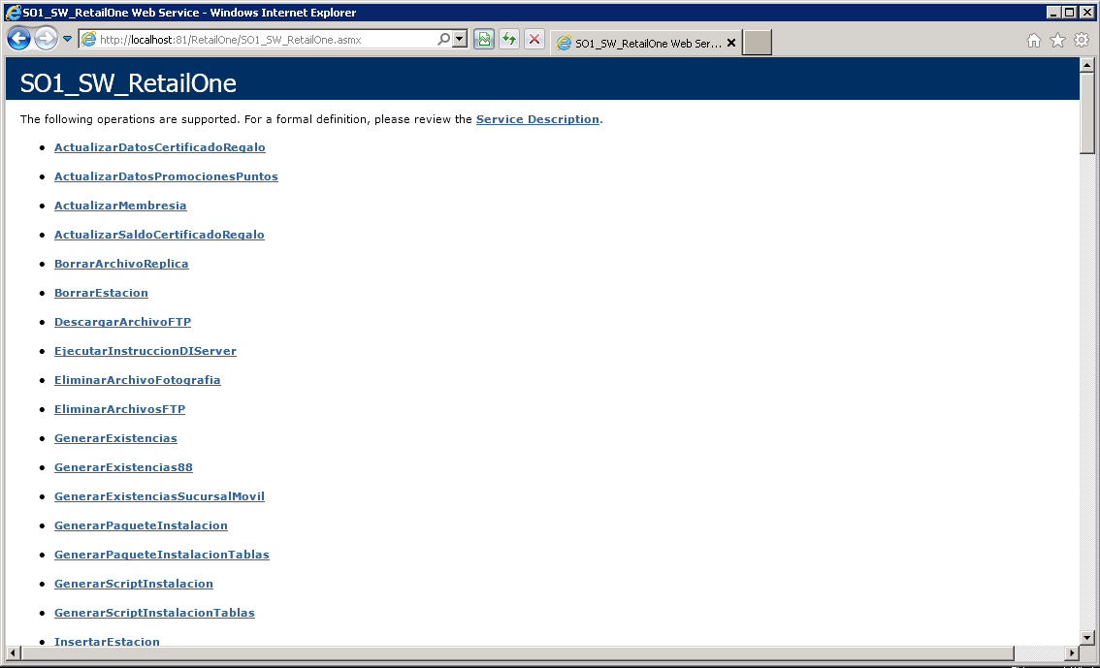

**DI SERVER COMPONENT CONFIGURATION**

On the SAP Business One server enter to \Control Panel\Administrative Tools -> Component Services

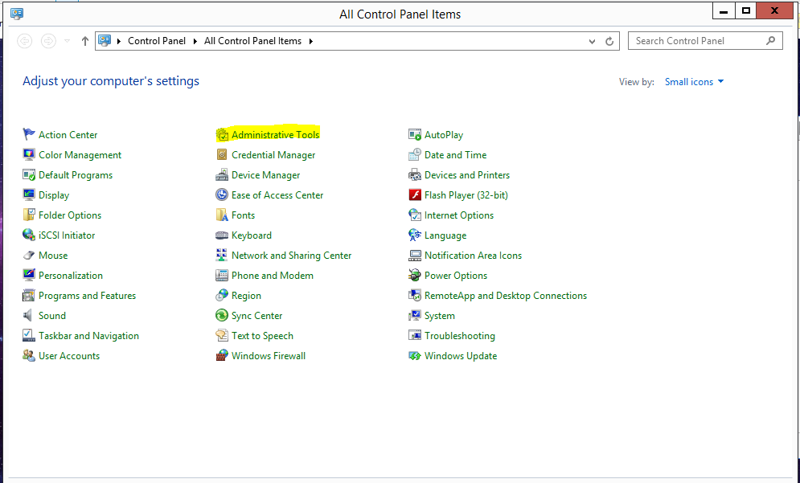

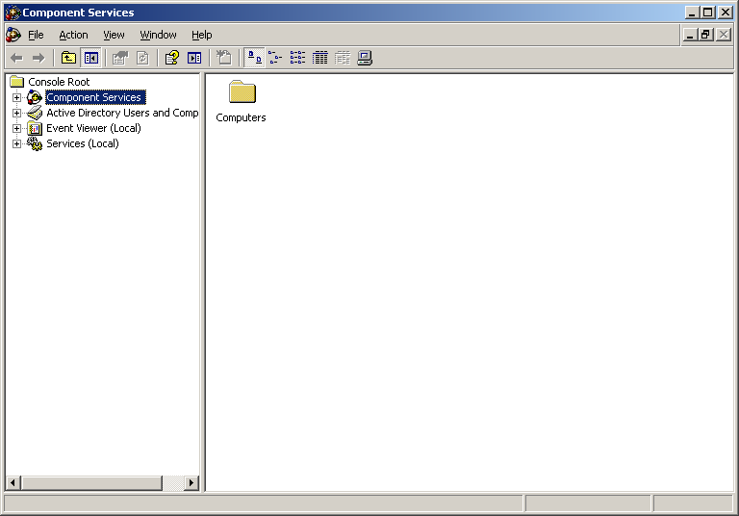

In the left panel navigate to the Root path of the console> Component Services> Computers> My Computer>DCOM Config and search the list on the right side for the SBODI_Server component.

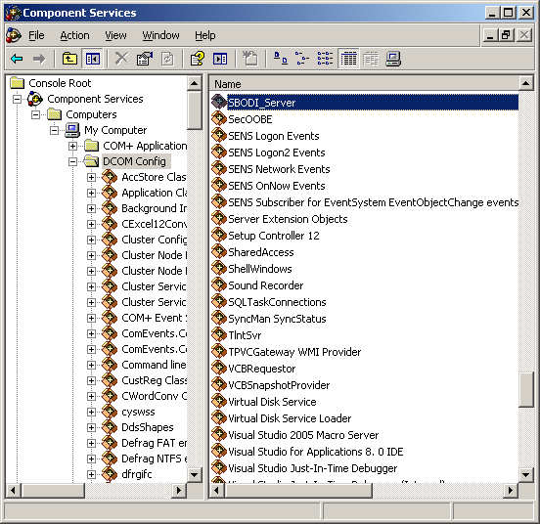

Enter the properties and in the security tab select the option of Customize for the permissions of initiation and activation; press the Edit button.

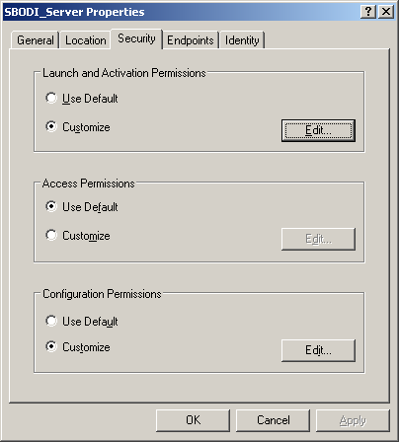

Add the Everyone user and assign Local Launch and Local Activation permissions; Press OK.

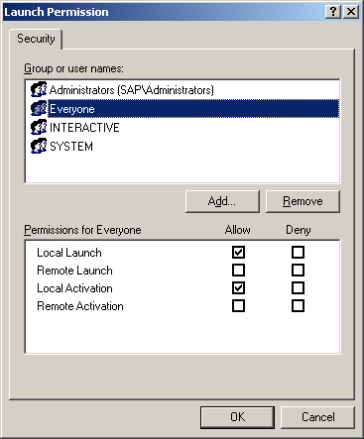

Again in the Security tab select the option Customize for the Configuration Permissions and add the user Everyone by assigning Full Control.

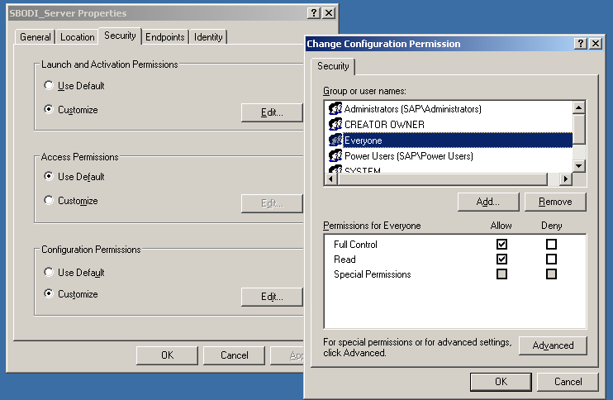

**ENABLE CLR INTEGRATION IN DATABASE SERVER**

Open the SQL Server console and connect to the corresponding database server.

Run the following SQL commands, one by one, on the master database.

SP_CONFIGURE 'CLR ENABLED', 1

RECONFIGURE WITH OVERRIDE

ALTER DATABASE [Database Name] SET TRUSTWORTHY ON

ALTER AUTHORIZATION ON DATABASE :: [Database Name] TO sa

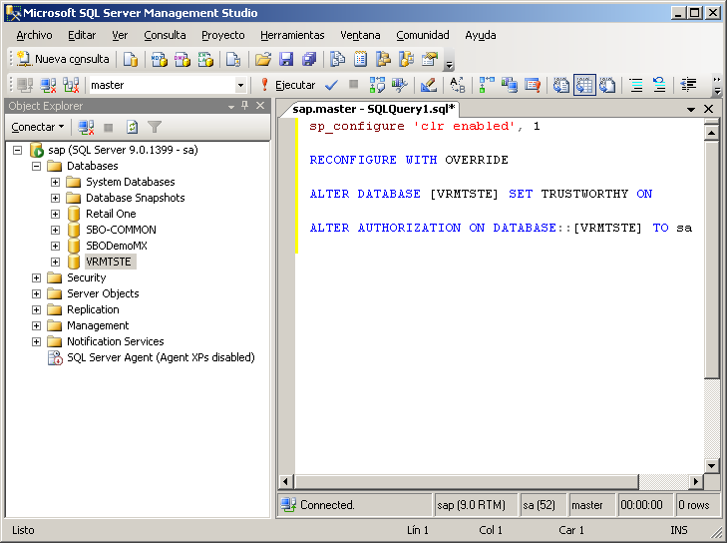

Once executed we proceed to Close SQL Server Console.

RETAIL ONE STRUCTURE ON SERVER

• ROOT DISC (C: D :)

• **"Retail One"** folder

• **"Central Console"** FOLDER; In case there are more than two consoles in production we will create the following structure:

• **"Consoles** “folder> inside we create the folder indicating in the name some reference of the installed company> "Central Console Retail One 1"> We will also rename the executable indicating in the name some reference of the installed company> "Retail One Central Console 1 .exe "

• **"License"** folder contains the following folders:

* Central License Installer
* Licensing (Licensing Application)

**• "Additional"** folder contains the following Folders:

* Central Database Installer
* SharedManagementObjects (Installation Additional)
* Crystal Components
* Utilities
* Run the bridgeCOM

• **"Retail One Add-on"** folder

• **"Central Sync"** folder; In case there are more than two consoles in production we will create the following structure:

• "Sync" folder> inside we create the folder indicating in the name some reference of the installed company> **"Central Sync 1"**

> General Contents of folders:

* **Input**
* **Output**
* **Log**
* **Historical**

**NOTE: In case of having different servers, the Synchronization folder will be hosted on the SQL server**

**CENTRAL DATABASE INSTALLATION**

Locate the Central Database installer in the path mentioned and run the application as administrator, we will see the installer as shown in the image:

* Server: Indicate the SQL server where the database is hosted
* License Server: Enter the name of the license server plus the port (3000)
* Database type: Indicate the SQL version (2005,2008,2012)
* Trust Connection: Enable if SQL accepts connection (Windows Authentication)
* Database User: Indicate the user SQL handler (sa)
* Database password: Specify the SQL handler start password

Press the button located at the top with ellipses, to enable companies.

* Company: Select the database to install
* SAP B1 User: Indicate the SAP user for the selected company (manager)
* SAP B1 Password: Enter the SAP password for the selected company

Click the Install button to start the installation. Use the Custom Installation tab to perform a part-based installation of the database.

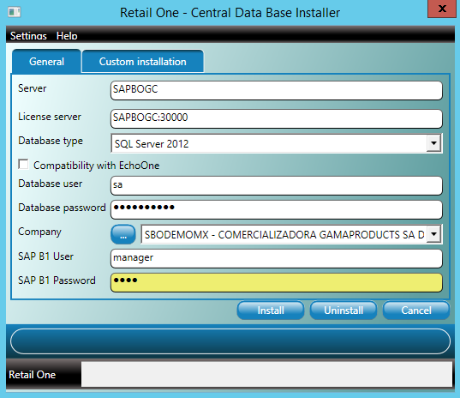

**CENTRAL CONSOLE CONFIGURATION**

Locate the Central Console and run the application "Retail One Console Central.exe"

In the connectivity section we will enter the URL of the previously created web service only until <http://localhost:81/RetailOne>; and we indicate the information requested in the configuration.

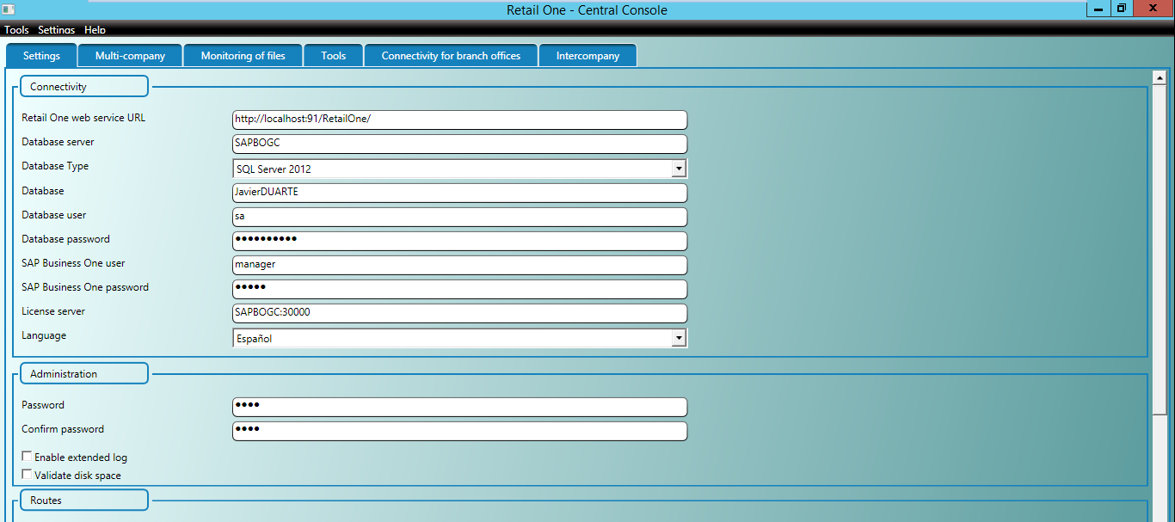

In the administration section we will indicate the password with which we will start the central console application when running.

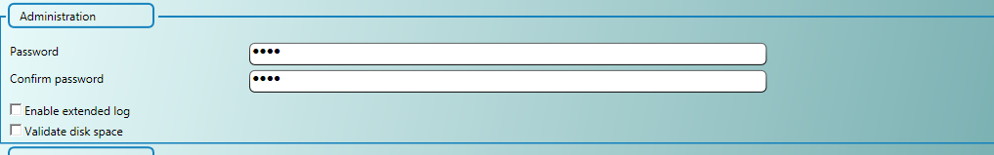

In the section of Routes we will indicate the route of the folders that were created previously; Entry, Exit, Logbook and Historic following the guidelines:

It’s recommended that the folders be located on the database server, if the database server and the SAP Business One server are different.

1. In case the SQL server and SAP are the same use the following configuration:
2. Input: Network path and use the same for Web Service
3. Output, Log and Historical: Local route and use the same for Web Service.

**b)** If the SQL server and SAP are different the configuration would be as follows:

1. Input: Network path on the SQL server, and check the Use same path for web service option
2. Output and Log: Local folder path on SQL server and uncheck the "Use same path for Web Service" option to use a network path for Web Service.
3. Historical: Folder network path on SQL server

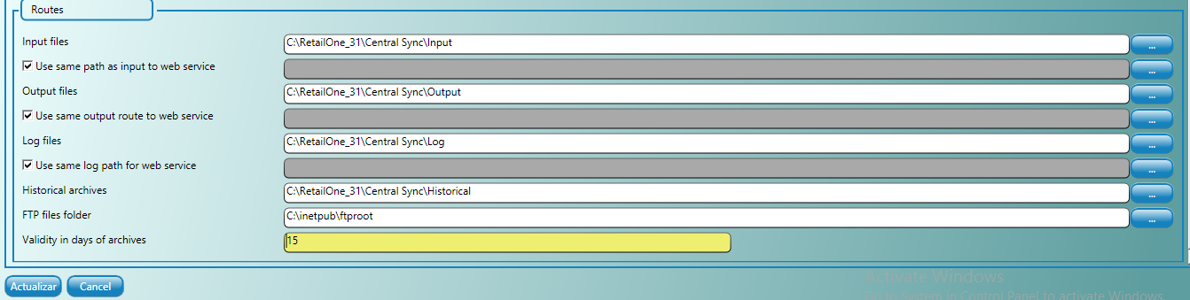

Press the Update button to save the data configured in the Central Console, the message "Operation Successfully Completed" will be displayed.

**REGISTRATION OBJECTS WIZARD**

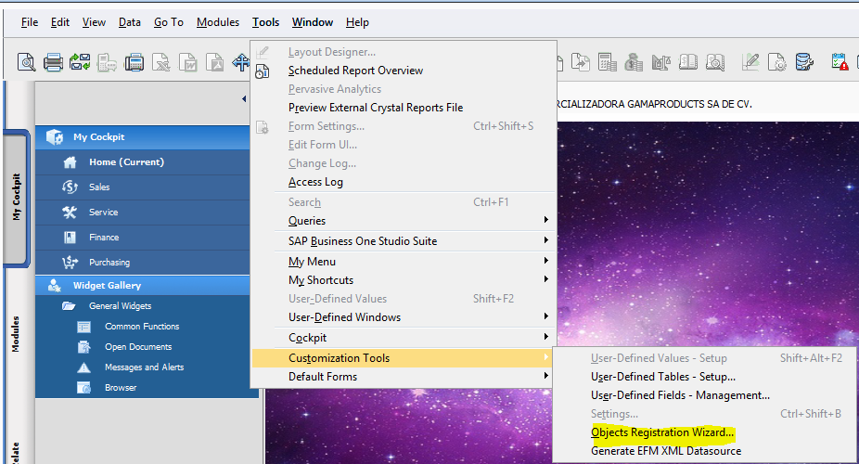

Log in to SAP Business One, then Tools >Customization Tools> Objects Registration Wizard

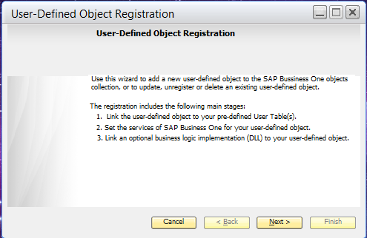

Click on Next button

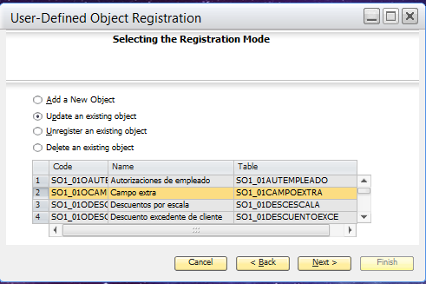

Select to Update an existing object, and the “Campo extra” Option; To start the wizard for that object.

Click on Next button.

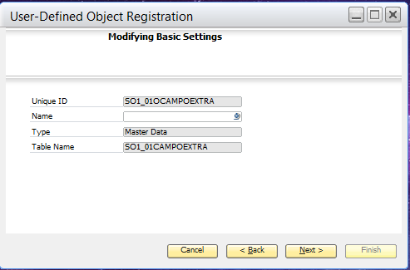

Modifying Basic Settings

Click on Next button

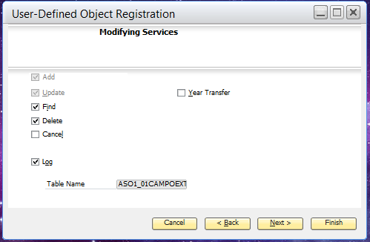

Modifying Services select the options as seen in the image.

Click on Next button.

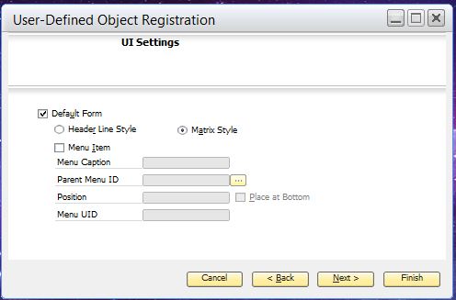

Click on Next button.

UI Settings: select Default Form option and select Matrix Style option.

Click on Next button.

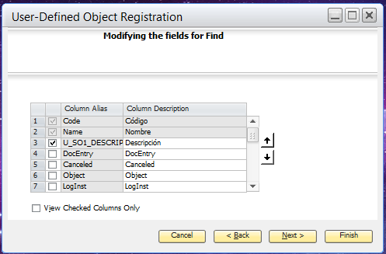

Select in the default forms the Name option, and the other fields referring to Retail One, which contain the denotation "U_SO1_".

Click on Next button

Select Code and Name in the section modifying the fields for Find

Click on Next button.

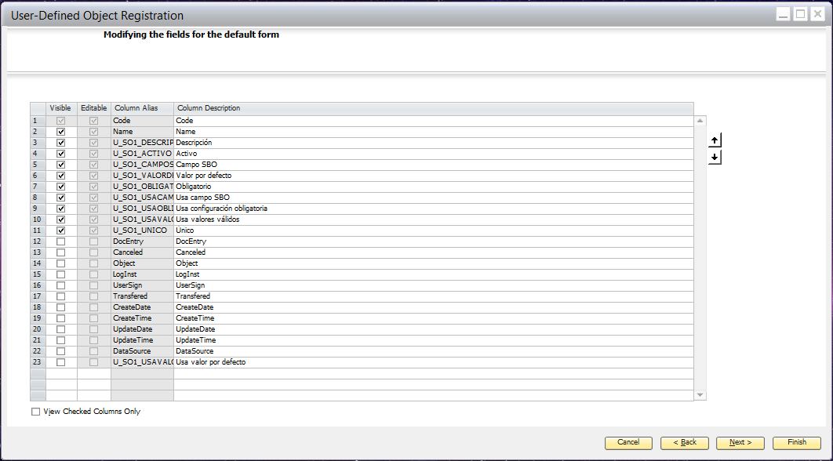

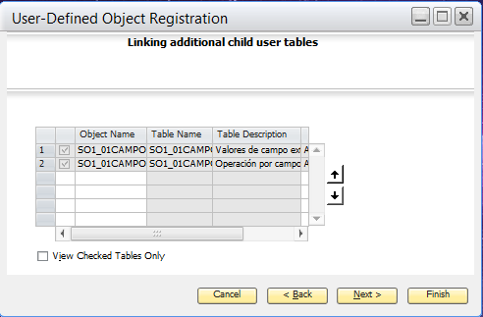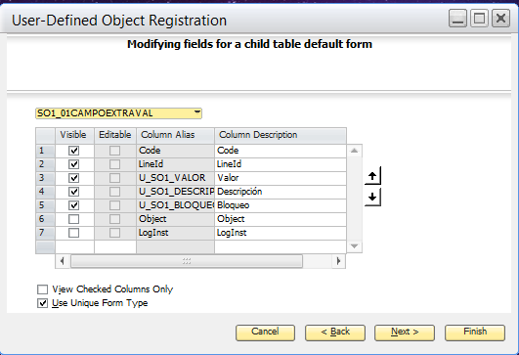

Modifying fields for a child table default select the option from the list SO1_01CAMPOEXTRAVAL, and check the boxes denoted with "U_SO1_".

Click on Next button.

Linking additional child user tables:

• ASO1_01CAMPOEXTRAVA

• ASO1_CAMPOEXTRAOP

Click on Next button.

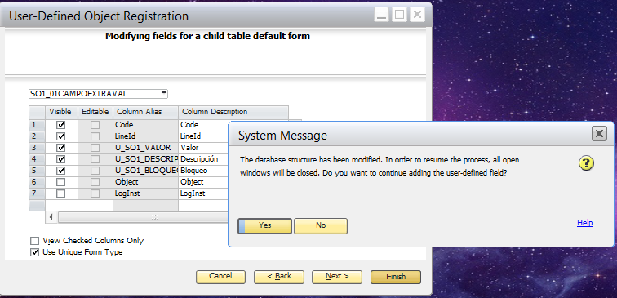

Complete the registration process, if necessary, use the Ignore option to continue the registration process.

PART II WORKSTATION

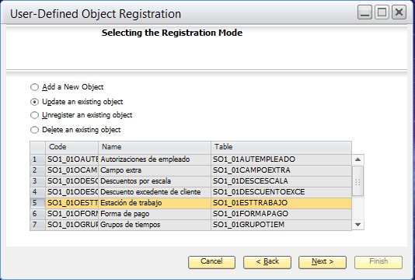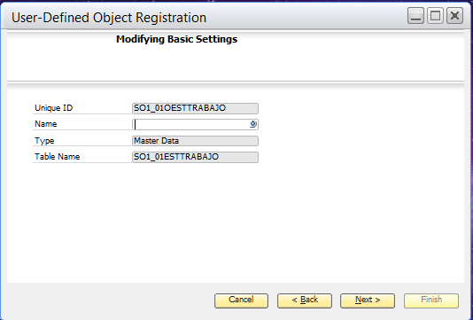

Modifying Basic Settings

Click on Next button

Log in to SAP Business One, then Tools> Customization Tools> Objects Registration Wizard

Select the "Update an existing object" option and select "Workstation".

Click on Next button.

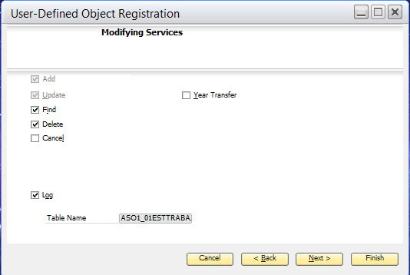

Modifying Services select the options as seen in the image.

Click on Next button.

Select the options as seen in the image, under "Modification Services"

Click on Next button.

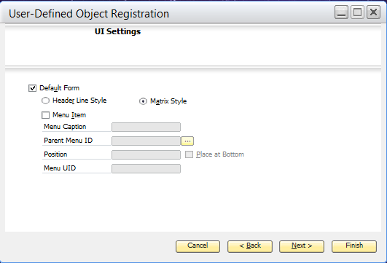 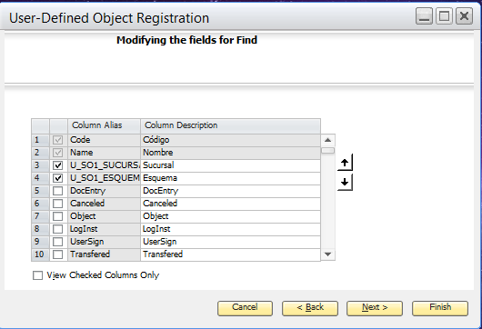

Select Code and Name in the section modifying the fields for Find

Click on Next button.

UI Settings: select Default Form option and select Matrix Style option.

Click on Next button.

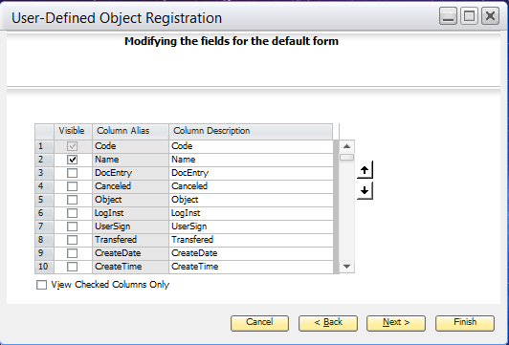

Select Code and Name, in Modifying the fields for the default form.

Click on Next button.

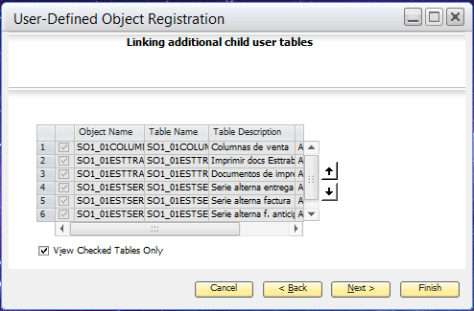 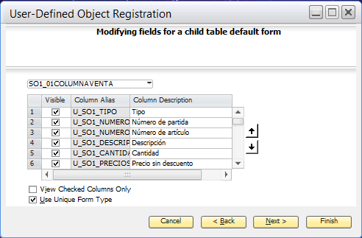

Modifying fields for a child table default form select, the table SO1_01COLUMNVENTA and the fields with the denotation "U_SO1_", all.

Click on Next button.

Linking additional child user tables, select the options as indicated in the image.

Click on Next button.

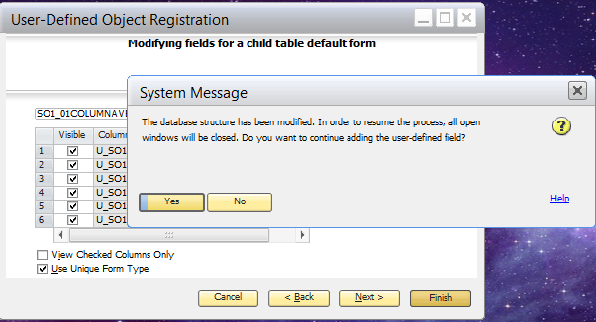

Complete the registration process, if necessary, use the Ignore option to continue the registration process.

PART III PAYMENT METHODS 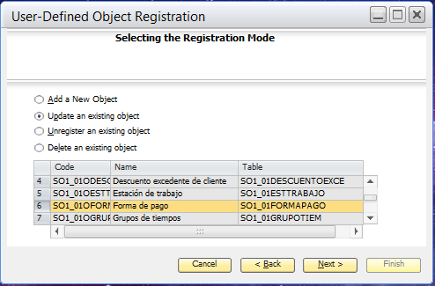

Log in to SAP Business One, then Tools> Customization Tools> Objects Registration Wizard

Select the option "Update an existing object", Select the option Forma de pago.

Click on next button.

Select the options as indicated in the image.

Click on next button.

Click on Next button

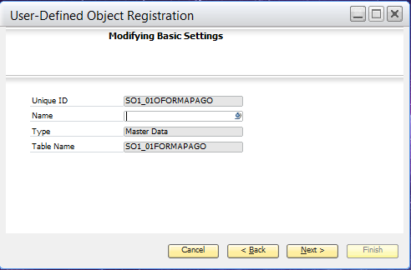 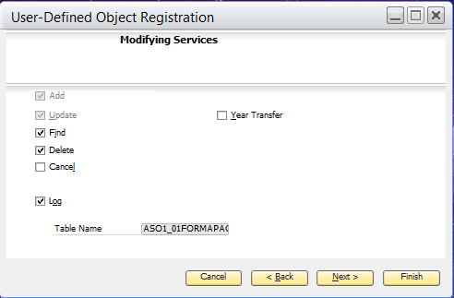

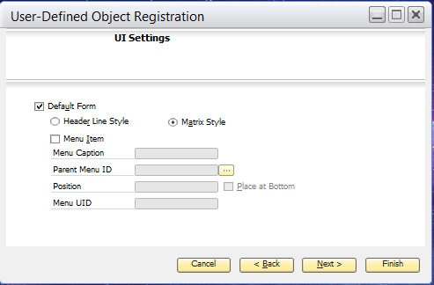 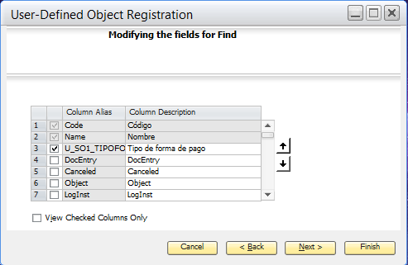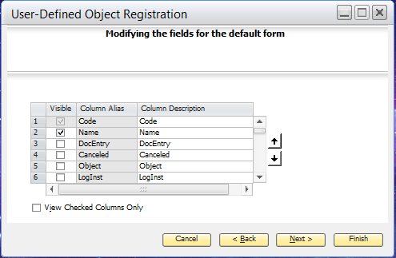 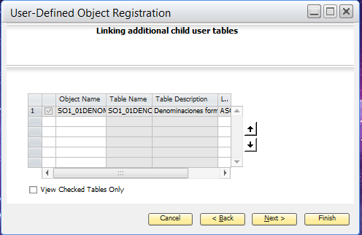 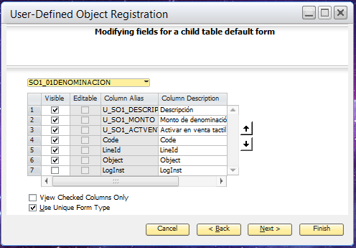 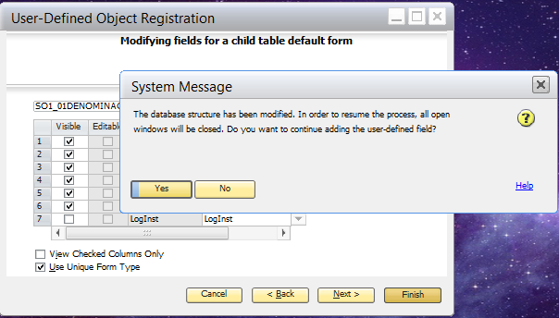

Select Code and Name.

Click on next button.

Select Code and Name, in "Modifying the fields to Find"

Click on next button.

Select the options as indicated in the image.

Click on next button.

Select the subordinate table A_SO1_01DENOMINATION.

Click on Next button.

Modifying fields for a child table default form select, select the options as seen in the image.

Click on Next button.

Complete the registration process, if necessary, use the Ignore option to continue the registration process.

PART IV STORE

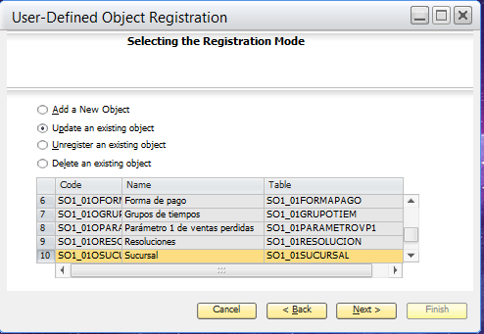 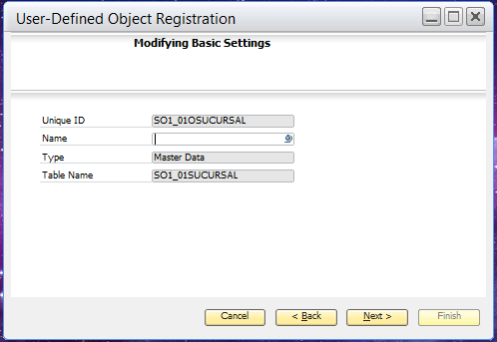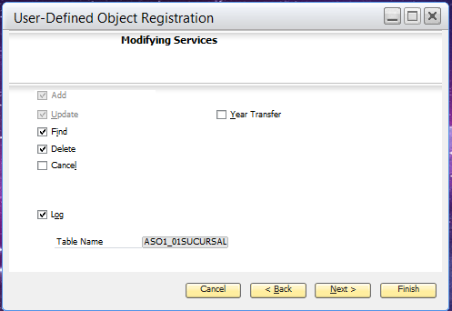 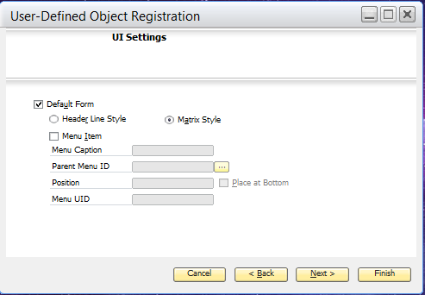 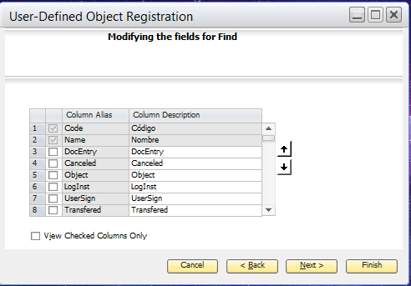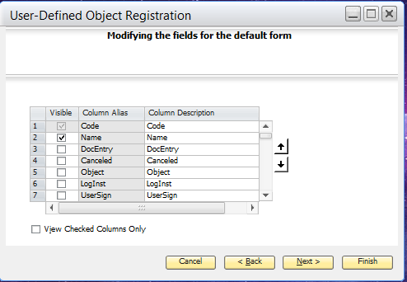 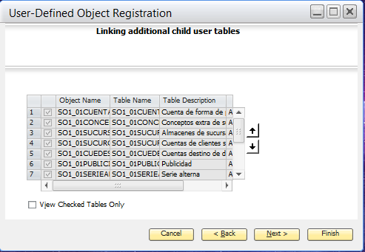

Select the options as seen in the image, under "Modifying services".

Click on Next button.

Click on next button. In "Modifying Basic Settings".

Log in to SAP Business One, then Tools> Customization Tools> Objects Registration Wizard

Select "Update an existing object" Select the Branch option.

Click on next button.

Select the options as seen in the image. In IU Settings.

Click on Next button.

Select Code and Name, in Modifying the fields to "Find".

Click on next button.

Select Codeand Name.

Click on next button.

In the subordinate tables section select the tables as indicated in the image.

Click on Next button.

In subordinate tables select the table SO1_01SUCURSALLIPRE, and in the fields select those denoted with "U_SO1_".

Click on Next button.

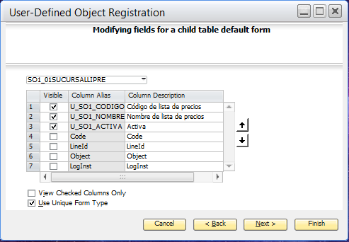

Select the options as seen in the image.

Click on Next button

En tablas subordinadas seleccione las opciones como se visualiza en la Imagen.

Pulse el botón Siguiente.

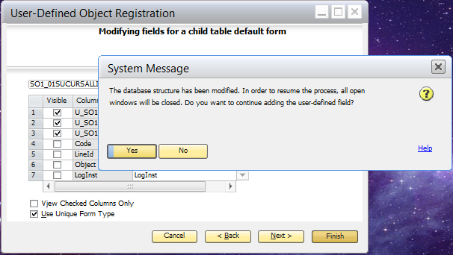

Complete the registration process, if necessary, use the Ignore option to continue the registration process.

PREVIOUS CONFIGURATION FOR RETAIL ONE ADDON

Run SAP Business One and Enter Human Resources> Employee Master Data> Select an Employee and Go to the Members tab> Define New Roles:

* Shipping Manager
* Destination Manager
* Driver

Assign roles to an employee:

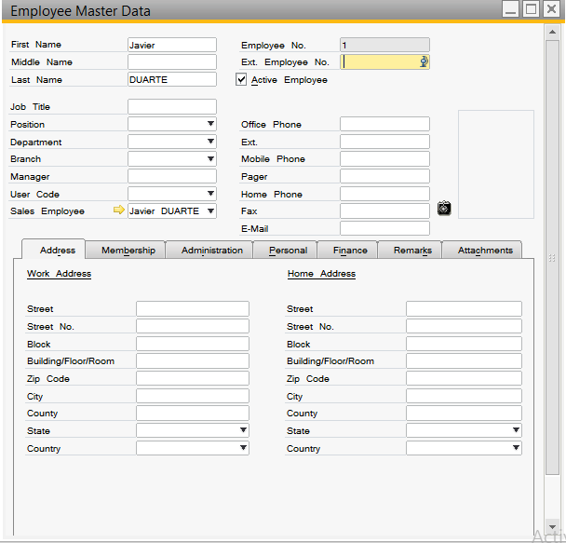

Also within the SAP configurations it’s necessary to create the Credit Cards, for the Card payment methods linked to Retail One. For that, go to SAP Business One Administration> Definitions> Bank Management> Credit Cards.

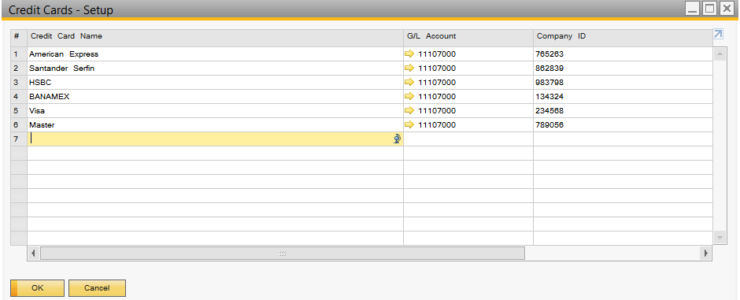

Then go to Administration> Setup> Banking> Credit card payment methods. And give a name to the credit cards created, in the previous option.

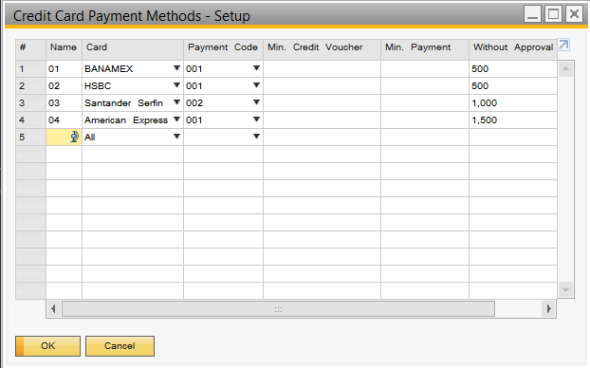

ADDON INITIALIZATION

To start with the RetailOne Addon, log in to SAP Business One> Then Locate the RetailOne Addon folder and Start the Application, double-clicking it will be displayed as the next image:

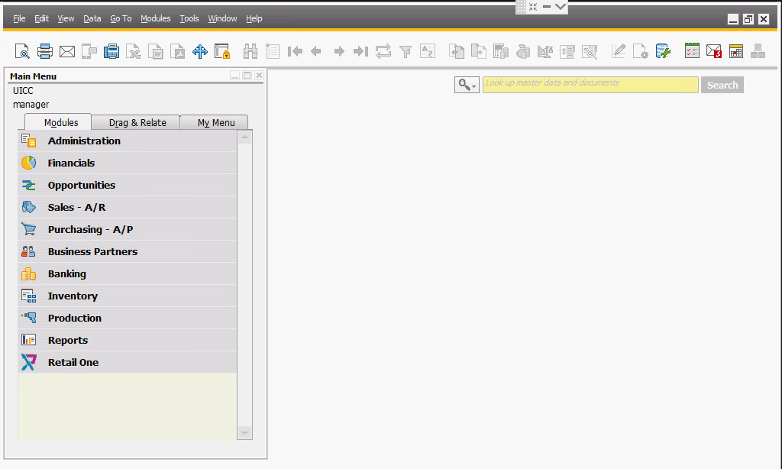

RetailOne Addon Modules

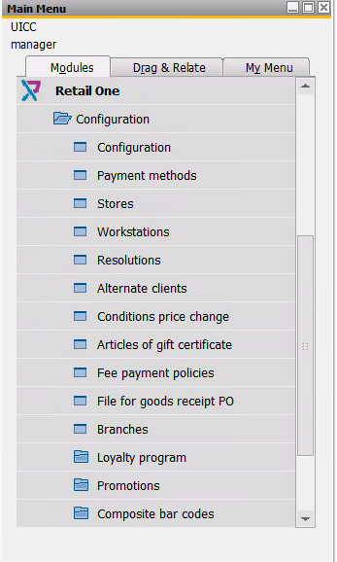

Enter RetailOne Addon> Settings> Configuration

• Configure the Roles parameters

• Activate the special keys option

• Configure the server parameters

• If necessary, set up the Electronic Billing section

• Configure the valid fields for validation of Electronic Invoice 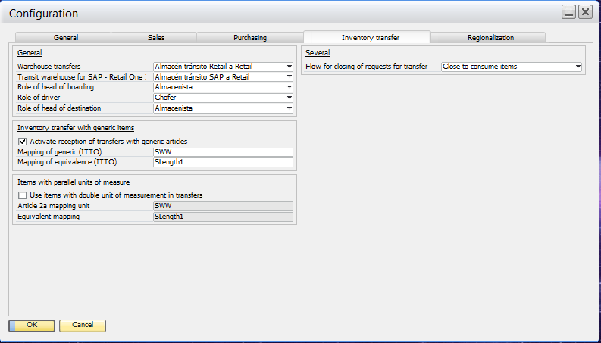

Enter RetailOne Addon> Settings> Payment Methods, Click the New button on the SAP toolbar.

Enter a code and a name and select the type of payment method.

• (CS) - CASH: Select this type to register the effective form of payment and in the "various" section select:

* Allow change
* Allows Money Movement
* Breakdown Cut Detail X
* In the Denominations Tab specify the denominations of payment method (only valid for cash type)

• (CH) - CHECK: Select the option to register the payment method Check.

• (CC) - CARD: Select the option to register the payment method Credit Card, select from the list the card referenced to the card, which was created previously.

• (OT) - OTHERS-F5: Use this option to register the Transfer payment method.

• (GC) - GIFT CERTIFICATE-F6: Use this option if you handle gift card

• (PT) - F7 POINTS: Use this type if the points option is handled.

• (RE) - REFUND: Select the option to indicate the return / change payment method.

• (DV) - Discount Vouchers: Use the option to register discount vouchers.

Select the Function key for the form of payment and also specify the Currency, Click the Create button to register the form of payment.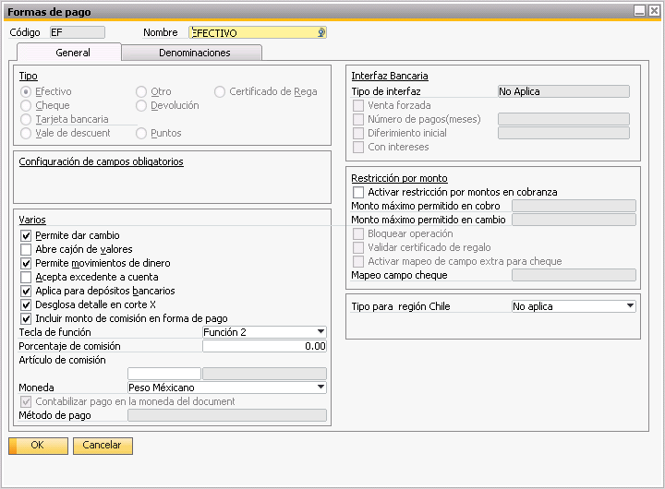 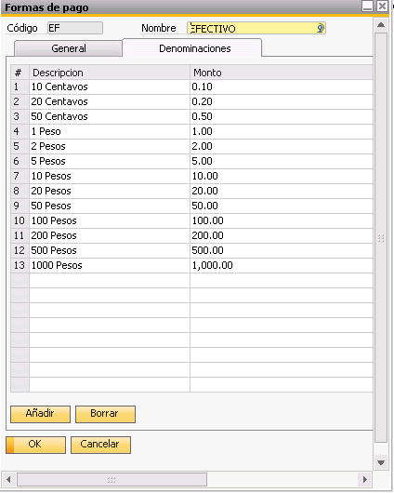

Enter RetailOne Addon> Configuration> Store, click the New button on the SAP toolbar.

• Enter the code and Name of the Branch.

• Select the business partner (customer, general public, frequent customer), who was previously discharged.

• Indicate the Rebilling account (in case it doesn’t exist it must be created in the last drawer).

• Indicate the number of lines per sale.

• Define the series of each document. (Documents tab)

• Define the accounts for each form of payment. (The Forms of payment tab)

• Specify the warehouse (s) related to the branch. (Warehouse tab)

• Indicate the validity of the documents and expedition place. (Additional tab)

• Activate the "Activate Default Vendor" option by selecting the "User" option. (Additional tab II).

• Activate the options "Activate customer account tax data" and "Enable article matrix detail section" in the various section, select an "Own bank" (Additional tab III).

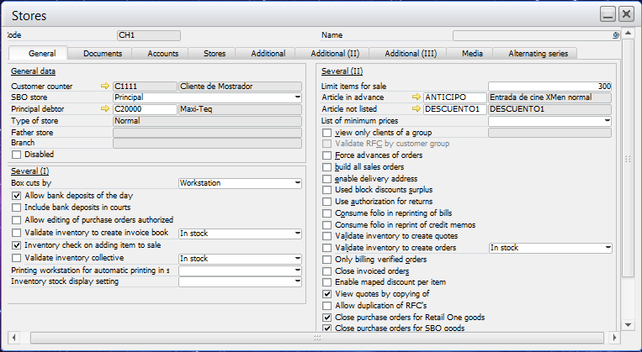

Enter RetailOne Addon> Configuration> Workstations, Click the New button on the SAP toolbar.

• Enter the code and Name of the workstation

• Select the linked branch, as well as the stores that you will use by default,

• Select the type option to indicate:

* Desk: Option to indicate that the workstation will not perform any kind of collection will only create documents which will later be charged in cash.
* Cash: Use the option to indicate that the workstation performs collections.

• Enable the search configuration option to expedite the search for an item at the time of sale.

• Configure the printers used in each generated document within the point of sale.

• Select flow control options, and select default payment methods.

• Select the options you want to display depending on the screen within RetailOne.

Press the Create Button to create the workstation.

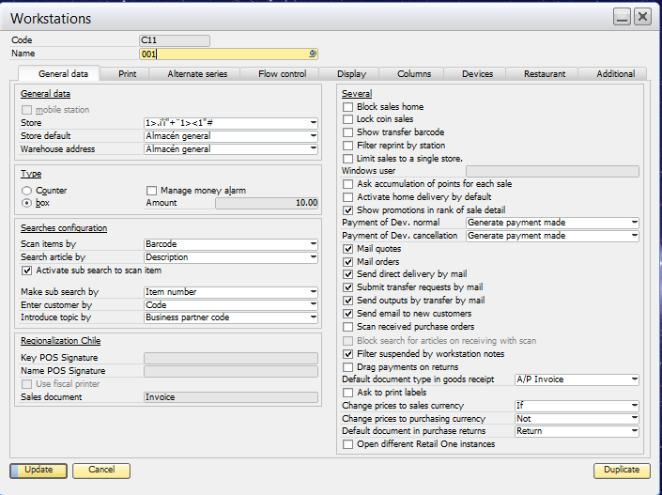

Enter RetailOne Addon> Configuration> Autorizations>Authorizations of employee, Click the New button on the SAP toolbar.

* Select the employee and enter the password
* Select the authorizations: Access to the modules of RetailOne
* Select the permissions: Actions that the user can perform, once it’s within some specific module

Click on the create button to create the Retail One user.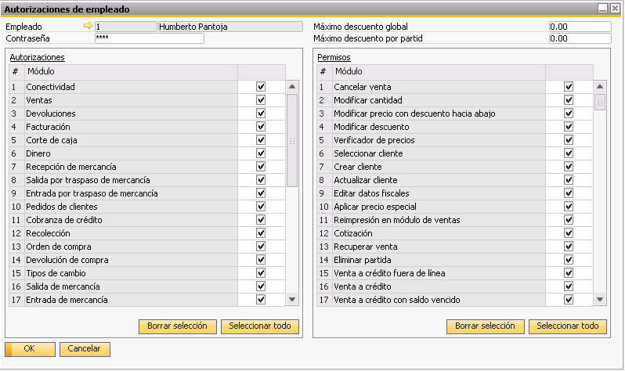

STRUCTURE OF RETAIL ONE IN POS

DATABASE AND WORKSTATION:

• ROOT DISC (C: D :)

• **"RetailOne"** folder

• **"Local Synchronizer"** folder

• **"Additionals"** folder contains the following Folders:

* **"Local Database Installer"**
* **"Local synchronizer service"**
* **"SharedManagementObjects"**
* Crystal Components
* Utilities (Restart License, Encryption, UUID Processor, Code 128, Printers)

• **"RetailOne"** folder

• **"Local Synchronization"** FOLDER, General Contents of FOLDERS:

* **"Input"**
* **"Output"**
* **"Log"**
* **"Historical"**
* **"Ads"**
* **"Reports"**
* **"Photo"**
* **"Certificates"**

ONLY WORK STATION:

• ROOT DISC (C: D :)

• **"Retail One"** folder

• **"Additionals"** folder contains the following Folders:

* "Local Database Installer"
* "SharedManagementObjects"
* Crystal Components
* Utilities (Restart License, Encryption, UUID Processor, Code 128, Printers)

• **"Retail One"** folder

STORE INSTALLATION AND CONFIGURATION

To start the Installation Run the Additional Components depending on the version of SQL installed. Ask the support and implementation area.

* Install SQLSysClrTypes
* Install SharedManagementObjects
* Install sqlncli
* Install Distributable Crystal Reports (CRRedist2008_x86)

Next we will execute the **"Installer of database Local.exe",** located in the route before mentioned. Run the application as Administrator. A wizard similar to the following image will be displayed, fill in the requested data:

A window will appear where we will put new installation or migration depending on what needs to be done like this.

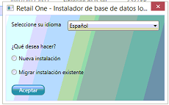

* New installation

* Then run the .exe again but with the option to migrate.

* + Central server URL, enter the URL of the server created previously, either by IP or HOSTNAME depending on the network structure. As shown in the image only to the Retail One part. Enter the local base server as well as the user and password of the same. Then click on Connect, once the connection is established the Ftp section is enabled (enter the corresponding information).
  + Indicate the type of Installation:
* Database and Workstation, Select the option if that computer will be the CASH and will also be where the local database will be hosted.
* Database only: select from the list the corresponding Branch to install.
* Only workstation: If the branch already exists and you want to install a CASH, linked to a branch.

• Click on Install; at the end, if it’s executed correctly, it will show the legend "Operation Completed Successfully", Click on Exit to close the application.

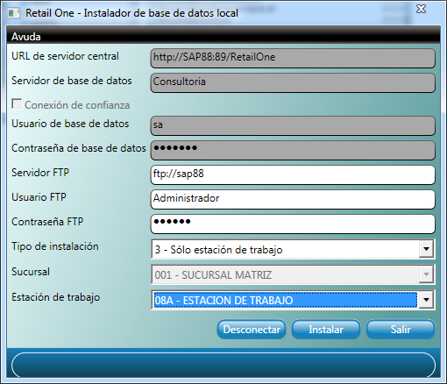

Next, we will configure our Local Synchronizer, which will be in charge of synchronizing the information between SAP and Retail One.

Locate the Local Synchronizer and run the application "Synchronizer Local.exe" in the taskbar we will find an Icon in Red color, to open the right click application> Show.

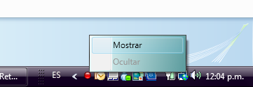

Enter the default password: Retail1_SL.

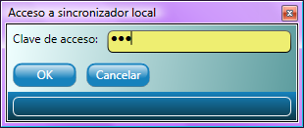

We will then configure our Local Synchronizer:

We will enter the URL of the web service, as well as the local database server, with respective user and password, also the FTP data will be configured.

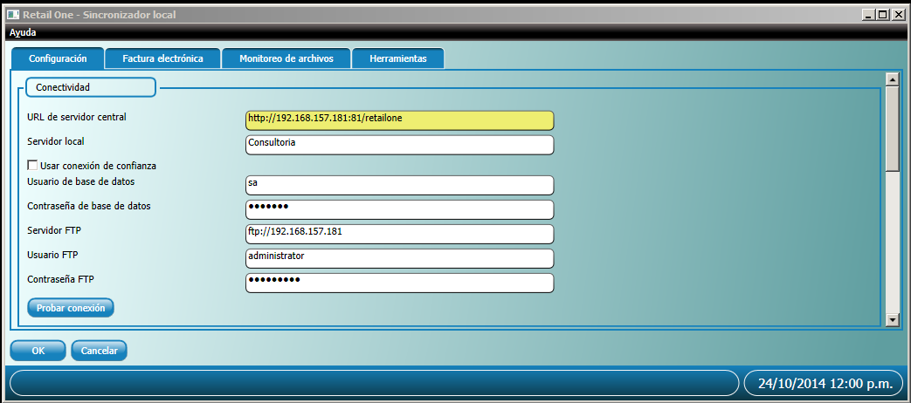

In the Administration section, we indicate the password with which we will enter the local synchronizer, and will also indicate the periods and frequencies of checking files.

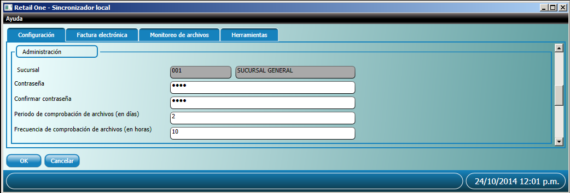

Routes indicate the path of the folders used for Synchronization, in a given case there are more than two computers connected to the same branch, indicate in shared mode the folders. Example: \\Consulting\RetailOne\LocalSync\Input; and so on with the other routes.

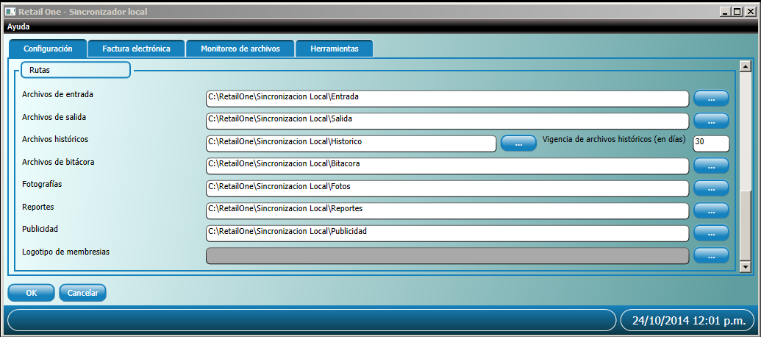

Press the Update Button to Finish with the Local Synchronizer Update process. A message indicating that the license server has not been configured is displayed, press the OK button. Then close our Local Synchronizer.

LOCAL SYNCHRONIZER SERVICE INSTALLATION

Locate our "Local synchronizer service", and run setup.exe, as administrator. The following Installation wizard will be displayed, click on the next button.

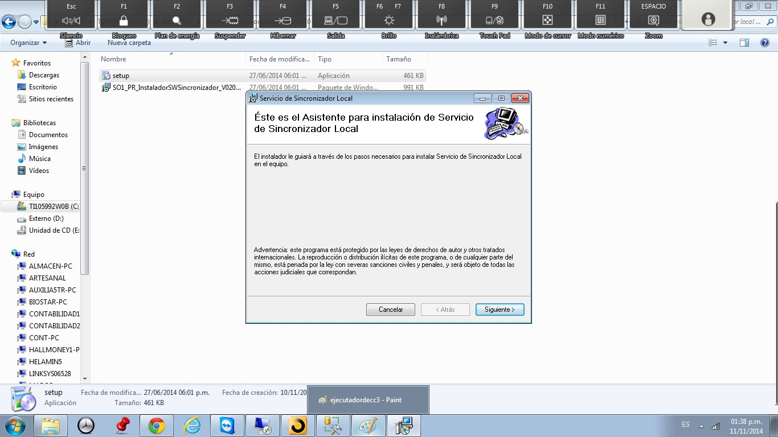

Then enter the path of the "local synchronizer" folder. Similar as shown in the image and select the option "For all users". Click on next button to continue.

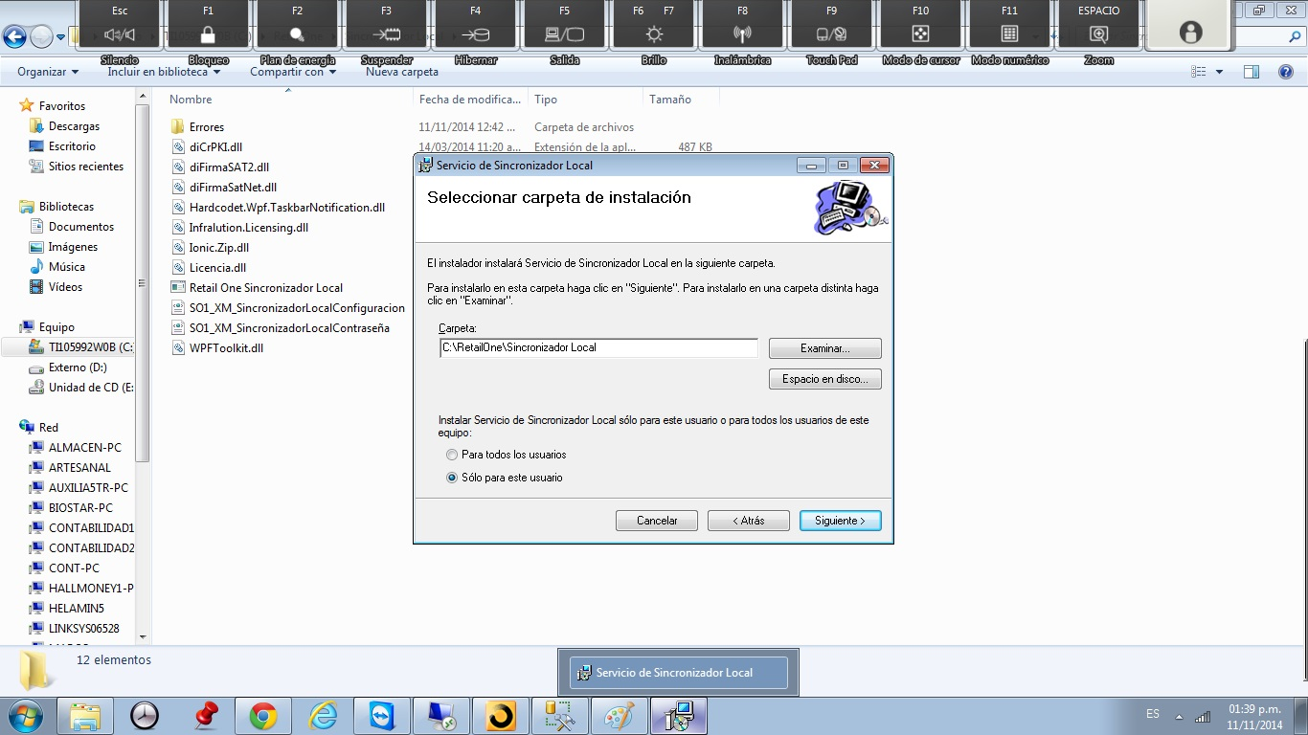

Press the close button when the installation has completely ended.

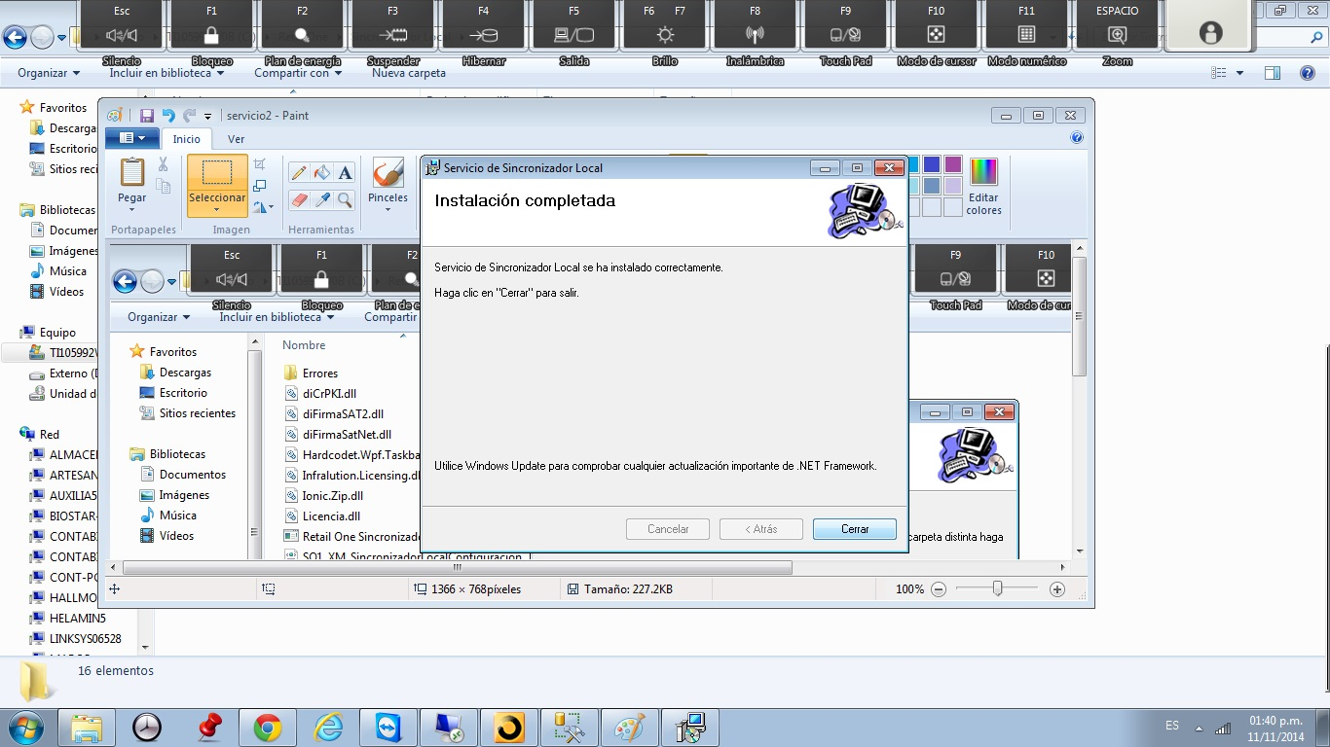

**Note**: If required Request the latest version of "SO1_PR_SynchronizerLocalR1 Service ..." and replace it in the local Synchronizer physical path, (C:\RetailOne\Local Synchronizer).

Afterwards initialize the service, from services of Windows, Locate it with the name "Local Synchronizer" of> Right Click> Properties. Modify startup to: Automatic, and initialize the service (Start button)

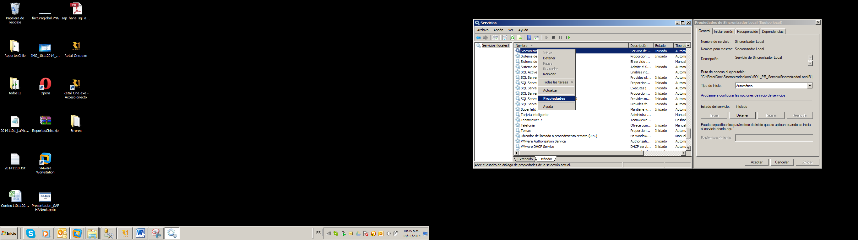

CONFIGURATION AND START OF RETAILONE

To start the RetailOne application, go to the path to it then to the XML folder and delete the SO1_XM_Connectivity.XML file ("C:\Retail One\Retail One\XML"). Then run the Retail One.exe application. When you start it, the message "Connectivity is not configured, please go to the connectivity module or call an administrator". Click on Accept.

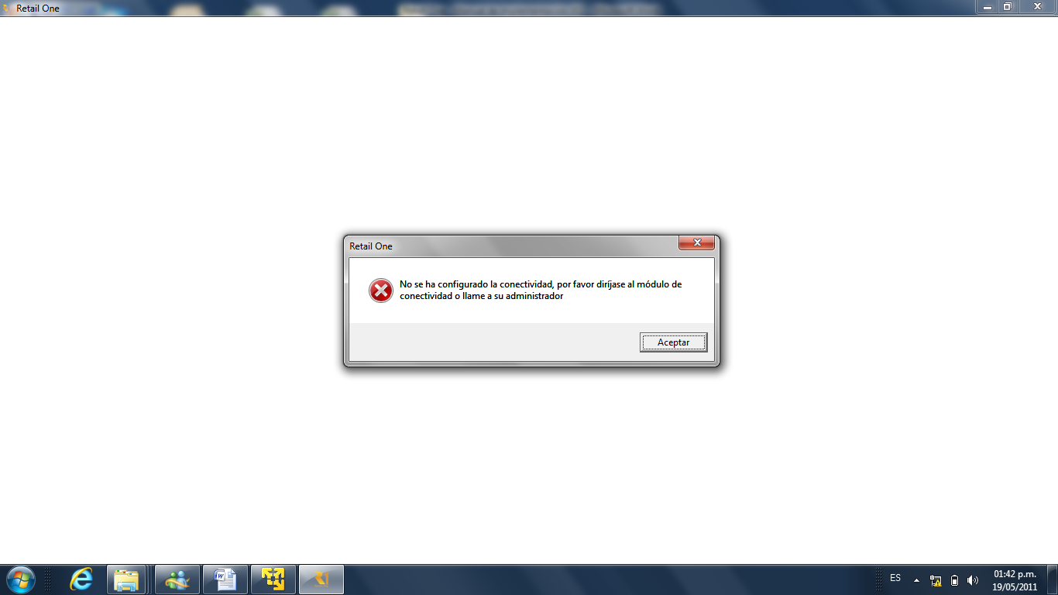

In the left menu of Retail One, expand the Administration section to click on the connectivity module (User and password will not be requested the first time).

On the connectivity screen enter the following parameters:

* Local branch database server (If you are working with the SQL Express version, do not forget to put SERVER_NAME \ SQLEXPRESS).
* If the connection is trusted, tick the box labeled "Use Trusted Connection"
* In case the connection is not trusted, configure a user and password of the administrative account "sa" of the SQL server.

Once you have finished configuring the parameters, press the refresh button. If the connection is successful, a green message with the caption "Operation completed successfully" will be sent, otherwise read the message and follow the instructions according to the connection error. Create a shortcut to the desktop to start the Application from there.

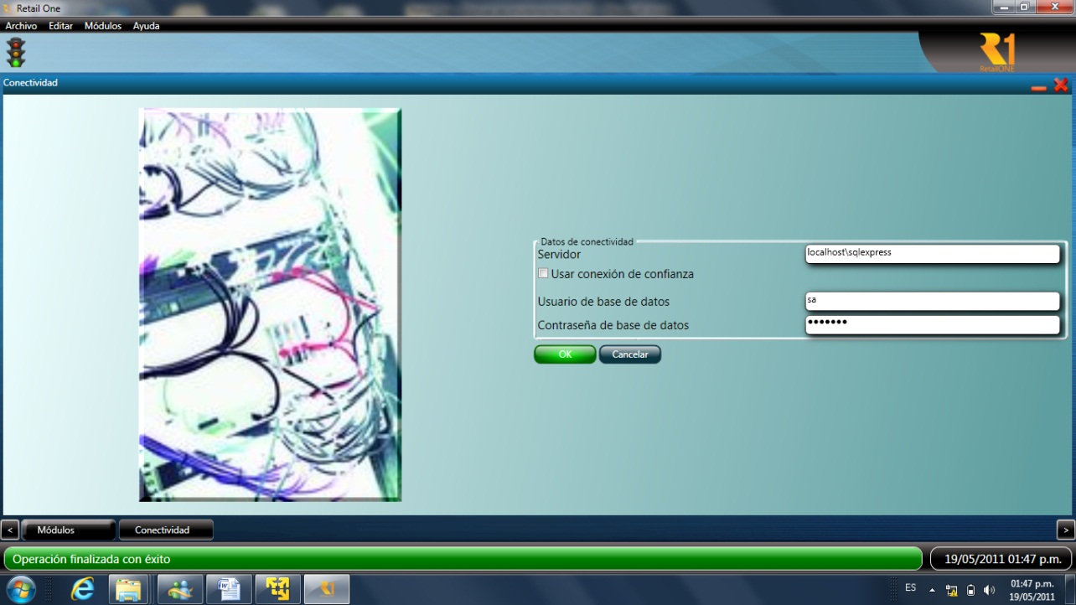

Once the connectivity is configured, you can use Retail One using the user codes created previously. For more information on using Retail One, see the help manuals.

GENERAL OBSERVATIONS

* + Each shared folder or use within the RetailOne settings is important, containing read and write permissions.
  + When handling multiple computers in a branch office, it is important to disable the Windows firewall and enable the "client protocols" options in "SQL Server Configuration Manager". And also, disable the firewall.
  + When you have several computers in a branch, inside the shared folder hosted on the branch server, you have to enter the branch through the network, for example, if the branch folder (Local Synchronizer) Configured more or less as: \\EQUIPMENT-PC\Local Synchronization\Input, this path must be accessible from any computer connected to it, remember to save the data of the computer credentials otherwise upon restart it will again have to enter the folder And reinsert the credentials.
  + Within the R1 folder, delete the file, Connectivity before initializing R1 (C:\ RetailOne\Retail One\XML) file: "SO1_XM_Connectivity.xml".
  + If the R1 folder in some branch; is copied to be used in a branch office in a new installation, remember to empty the contents of the (Entry, Exit, Logbook, and Historic) folders. As well as any folder that is "Errors". Also remember to delete the files in the local synchronizer folder before running the new installation:
* Retail One Synchronizer Local.exe.config
* The SO1_PR_SynchronizerServiceLocalR1_V020000.exe
* SO1_PR_SynchronizerServiceLocalR1_V020000.exe.config
* SO1_XM_SynchronizerLocalConfiguration.xml